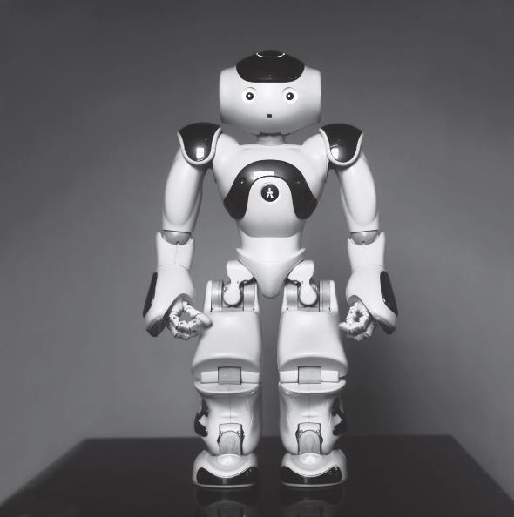
Robot pic:

Source: Harvard Business Review

